Pranaam Hospital Token SYSTEM

Table of Contents

1. About: 2

2. Benefits: 2

3. Modules: 2

a. Patients View 3

b. Doctors View and Controller 4

c. Controller 5

5. High Level Architecture Diagram 7

6. Hardware Requirement 8

7. Effort Estimation 8

# About:

Token system is a product which will ease the customers in getting a token number and viewing their details on screen.

# Benefits:

1. Customers don’t have to spend long time waiting in a queue
2. Customers can know their status on screen
3. Customers can know the status of Dr on the screen
4. Customers can easily know when their turn would be coming
5. Different sources of appointment booking will be combined into one.
6. Doctors can know the number of patients waiting, even from their home.
7. Doctors can set their status in case they are busy with something else.

# Modules:

Token System will have 3 modules.

1. Patients View
   1. Patient View Screen 1: Overview
   2. Patient View Screen 2: Token Details
2. Doctors View and Controller
   1. Doctors View Screen 1: Overview
   2. Doctors View Screen 2: Token Details and Controller
3. Receptionist Controller
4. Doctors Mobile View

# Patients View

View Module is only for displaying the details on the screen. It will display Now Serving Token, Next Token, Status, Patient Name, Dr Name and Approx. Wait Time

There will be 2 views: Patient View Screen 1 (Overview) and Patient View Screen 2(Token Details)

**Patient View Screen 1 :** [Overview] This will be a simple view where it will display only current token number and next token number for each doctor.

|  |  |  |  |
| --- | --- | --- | --- |
| Doctor Name | Room No | Now Serving | Next Token |
| Dr. Manish Gour | 1 | PD1 | PD2 |
| Dr. Praggya | 2 | GY1 | GY2 |
| Dr. Arif | 3 | PN1 | PN2 |

**Patient View Screen 2:** [Token Details] This view helps the next patient to be attentive.

|  |  |  |  |
| --- | --- | --- | --- |
| Status | Token Number | Patient Name | Dr Name |
|  | PD1 | John | Dr.Manish Gour |
|  | GY1 | Savitri | Dr.Praggya Gour |
|  | PD2 | Kalyan | Dr.Manish Gour |
|  | GY3 | Laxmi | Dr.Praggya Gour |
|  | GY2 | Seeta | Dr.Praggya Gour |

**View Details**

1. In Token Number column PD – Pediatrician, GY – Gynecology, OR – Orthopedic, PN – Physician, ED – Endocrinology, EN – ENT, DN – Dentist, DI- Dietician
2. The View will be displayed in English, Telugu and Hindi languages.
3. Each Language screen will pause for 30 secs.
4. It will display 20-30 patient details on the screen
5. In Status column, Green – Check-in/In Progress, Yellow – Waiting, Red – Missed Appointment.

Both the views will be shown on the screen. The upper section will display View 1 and the lower section will display View 2.

# Doctors View and Controller

It will give the total number of patients waiting for each Doctor.

Doctors should be able to check this from home or from anywhere.

**Doctors View : Screen 1 (overview)**

|  |  |
| --- | --- |
| Doctor Name | Patients Waiting |
| Dr. Manish Gour |  |
| Dr. Praggya Gour |  |
| Dr. Naga Kiran |  |
| Dr. Arif |  |

Details

1. Dr should login with their passcode to know these details
2. If Dr Manish logs in, he cannot check the other Doctors patients details and cannot control. He will just know the number of patients waiting.
3. When Dr clicks on the Patients Waiting number, then it should show the full details of the patients [it will take the Dr to Screen 2]

**Doctors View: Screen 2 (Token Details and Dr Controller)**

Available

Emergency

Current Status: Available

|  |  |  |
| --- | --- | --- |
| Token Number | Patient Name | Status [Please click when Done] |
| PD1 | John | Completed |
| PD2 | Kalyan | Missed  In Progress |
| PD3 | Ram | Waiting |
| PD4 | Laxman | Waiting |
| PD5 | Peter | Waiting |

1. Initially the status of any patient will be in “Waiting” state, when Dr clicks on Call then the status would turn “In Progress” and also “Missed” button will be displayed.

During this stage, both “In Progress” Button, “Call” button would be Disabled and “Missed” button would be enabled. [Incase Patient doesn’t come, Dr can click on Missed button and status will be shown as RED in the View Screen 2 and the next Patient gets enabled.

When Dr clicks on “Call” button of next token number, then “In Progress” would turn into “Completed” and the next Token’s status will turn into “In Progress”

# Controller

This will allow the Receptionist to enter/modify the patient details in the token system.

Currently Patients visit hospital via different sources, example

Walkin

Pranaam Website

Just Dial

Phone Booking

Practo

Zify

Kare4U

Etc

This controller will have 2 modules

1. Self-Check-in by Patients
2. Check-in by Receptionist

**Self-Check-In by Patients:**

Patients can enter the details in the system and can get the Token number

Patients have to enter the below details to get the Token number

*PHUID, Patient Name, Phone Number, Dr Name.*

New Patient: If New Patient, they will take the help of Receptionist to get a PHUID. [or we can create a form for new patients]

Existing Patient

*PHUID, Patient Name, Phone Number, Dr Name, TimeSlot*.

Timeslot options : ASAP, 1hr gap from current time, next day any 5 mins time slot.

After entering the above details, a Token number will be generated.

|  |  |  |  |  |  |
| --- | --- | --- | --- | --- | --- |
| Patient Name | PHUID | Phone Number | Dr Name | Time Slot | Action |
| Ram | 2343 | 9999999999 | Dr.Manish | ASAP | Modify |
| Laxman | 34523 | 8888888888 | Dr.Praggya | ASAP | Modify |

**Check-in by Receptionist**

1. Receptionistcan enter the below details in the system and can get the Token number

*PHUID, Patient Name, Phone Number, Dr Name.*

After entering the above details, a Token number will be generated.

1. Receptionist will also have the option to modify or delete the token details.
2. Time slot options:

Current Day: ASAP, 5 mins gap from current time, next 10 days any 5 mins timeslot

1. There will also be a search option for Receptionist.
   1. Search Using Mobile Number, Patient Name, PHUID

|  |  |  |  |  |  |  |
| --- | --- | --- | --- | --- | --- | --- |
| Patient Name | PHUID | Phone Number | Dr Name | Time Slot | Action | |
| Ram | 2343 | 9999999999 | Dr.Manish | ASAP | Modify | Delete |
| Laxman | 34523 | 8888888888 | Dr.Praggya | 2-10-2016  10:05 AM | Modify | Delete |

Assuming current day is 1-10-2016

# **High Level Architecture Diagram**

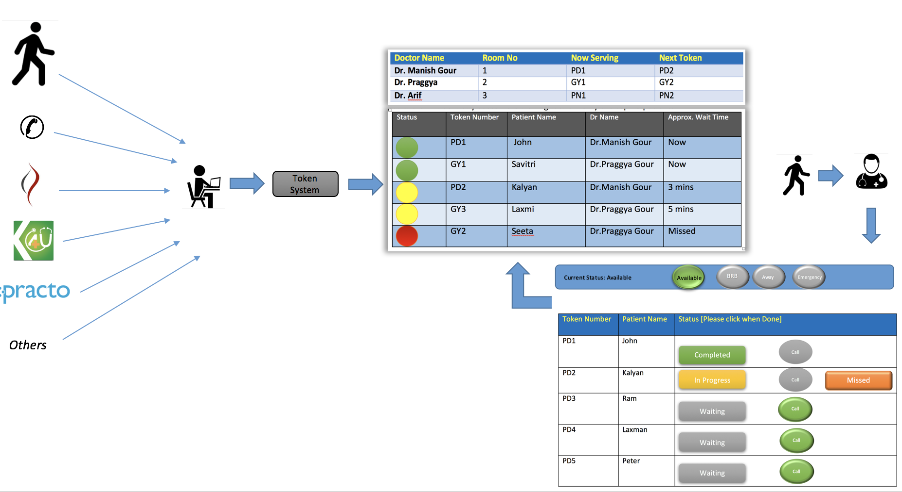

# **Hardware Requirement**

Tablet Devices: 4

Doctor: 1

Receptionist: 1

Self-Check in: 1

Extra: 1

Desktop: 1

Device to connect Desktop and TV :

Tablet Device holder / Stand: 1

Server Requirement: We can use one of our existing machines as the server.

# **Effort Estimation**

*Still working on this*